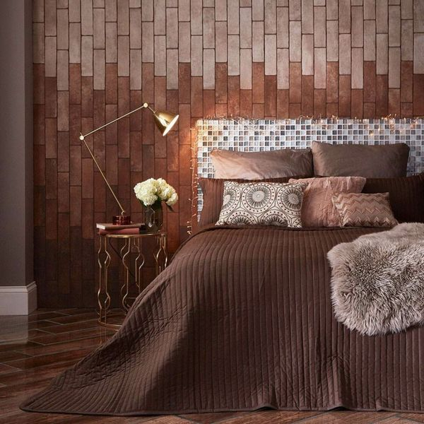

Bourbon Brown Brick Tiles: <https://www.wallsandfloors.co.uk/avenue-tiles-bourbon-brown-brick-tiles>

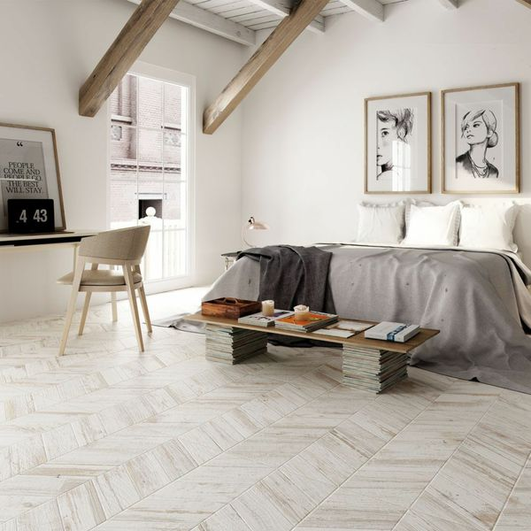

White Wash Chevron Wood Tiles: <https://www.wallsandfloors.co.uk/bococa-paintwash-wood-effect-tiles-white-wash-chevron-wood-tiles>

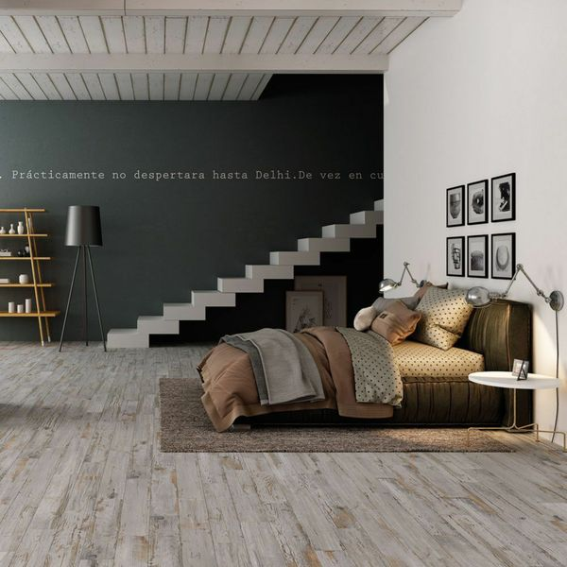

Grey Tempera Chevron Wood Tiles: <https://www.wallsandfloors.co.uk/bococa-paintwash-wood-effect-tiles-grey-tempera-chevron-wood-tiles>

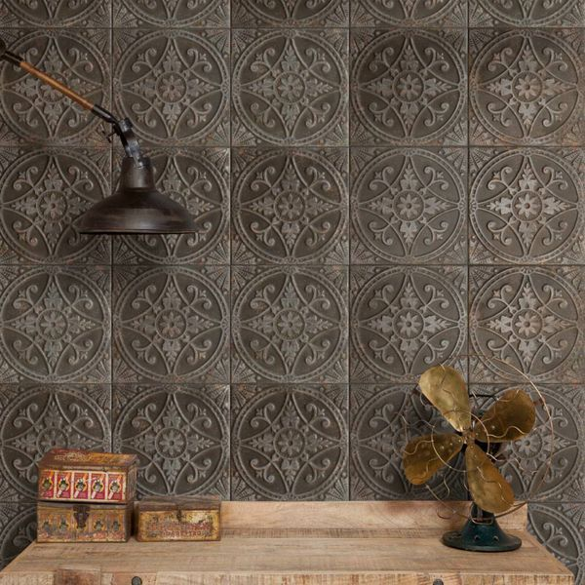

Pressed Patina Steel Tiles: <https://www.wallsandfloors.co.uk/pressed-patina-steel-tiles>

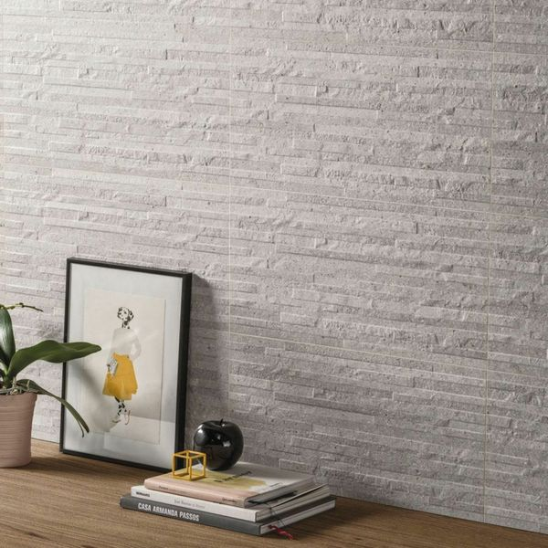

Troverta Muretto Ash Tiles: <https://www.wallsandfloors.co.uk/troverta-muretto-ash-60x30-tiles>

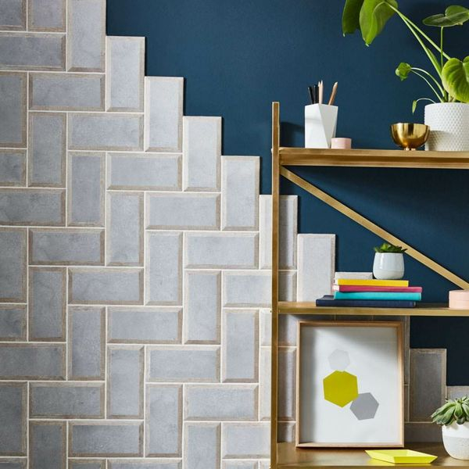

Mixx Concrete Oak Wood Tiles: <https://www.wallsandfloors.co.uk/mixx-concrete-oak-wood-tiles>